Appendix VII: The Rest of the ALICE Detector

Looking at the ALICE detector geometry in more detail, we first find, closest to the collision area, a central barrel part for measuring photons, electrons, hadrons, as well as a forward muon spectrometer, all of which is embedded in a large solenoid magnet and which covers polar angles between 45°-135°. Moving outward from the first layer of the central barrel, we find an inner tracking system (ITS, Figure 1), consisting of 6 planes of silicon pixel detectors (SPD), silicon drift detectors (SDD) and silicon strip detectors (SSD), which provide for high resolution particle detection [27].

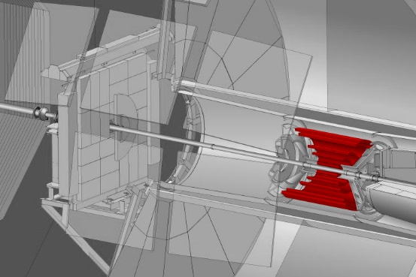

Figure 1: ALICE Inner Tracking System (SPD, SDD, SSD)

The main functions of the ITS are: 1) the reconstruction of secondary vertices in the decay of strange- and heavy flavour particles, 2) particle identification and tracking of particles with low momentum, and 3) improving the resolution of impact parameters and momentum. The outer SSD detectors have analog readout for particle identification via dE/dx (see section **Error! Reference source not found.** **Error! Reference source not found.**), in the non-relativistic (i.e. low ) region.

Next, as we move outwards, we find the Time-Projection Chamber (TPC, Figure 2).

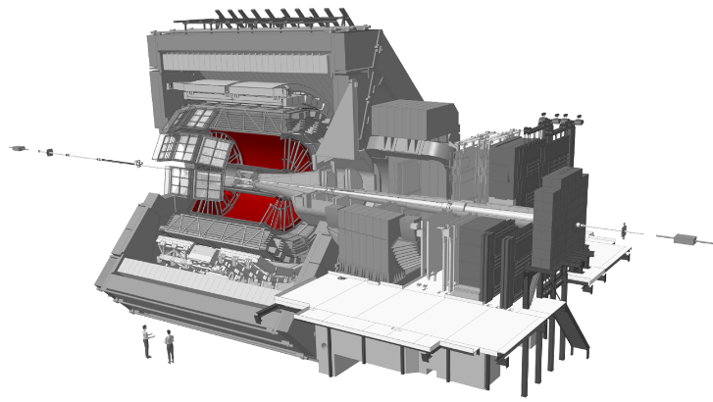

Figure 2: ALICE TPC

As the main tracking detector, the TPC is a conservative system, sacrificing data volume and speed for redundant tracking mechanisms, which guarantee reliable performance, by ensuring good double-track resolution and by minimising space charge distortions [27].

After the TPC, we find three Time of Flight (TOF) particle identification arrays (Figure 3).

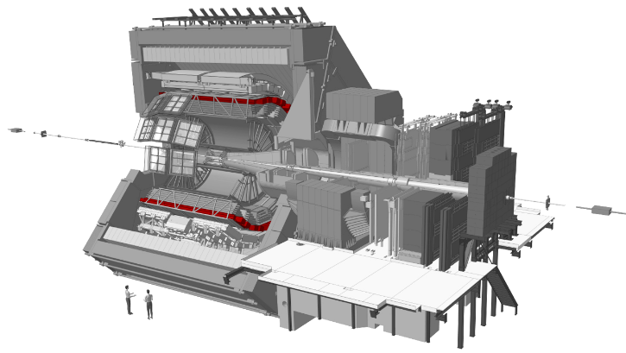

Figure 3: ALICE TOF

Optimized for large acceptance and particle identification in the average momentum range, the TOF covers an area of 140 m² with 160 000 individual cells, the TOF offers time resolution of 100 ps.

Next, we find Ring Imaging Cherenkov Detectors (HMPID, Figure 4).

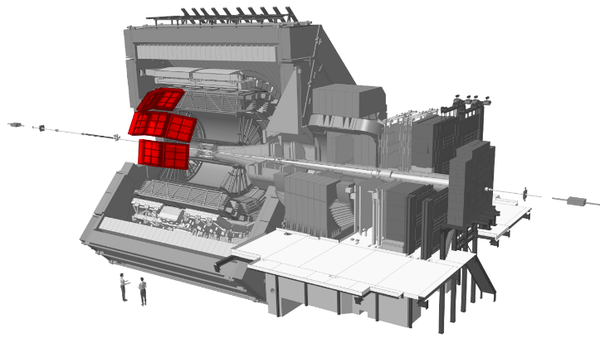

Figure 4: ALICE HMPID Invalid source specified..

A single-arm detector consisting of an array of proximity focusing ring imaging Cherenkov counters, the HMPID extends particle identification (especially the identification of hadrons) towards a higher spectrum of momentum [27].

After the HMPID detectors, we get to the Transition Radiation Detector (TRD, Figure 5), part of the overarching topics of this dissertation.

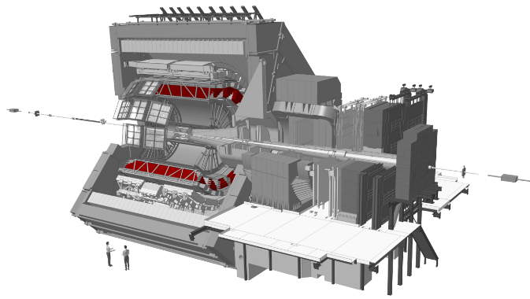

Figure 5: ALICE TRD

The TRD identifies electrons of high momentum, above 1 GeV/c, to quantify production rates of quarkonia and heavy quarks in the mid rapidity (relativistic velocity) range [27]. Six time expansion wire chambers filled with are used in conjunction with attendant composite polystyrene radiators to distinguish electrons from other particles by comparing their actual energy deposition in the detector to their characteristic dE/dx curves [27].

The outer layers of the central barrel are occupied by two electromagnetic calorimeters (PHOS, Figure 6, and EMCal, Figure 7).

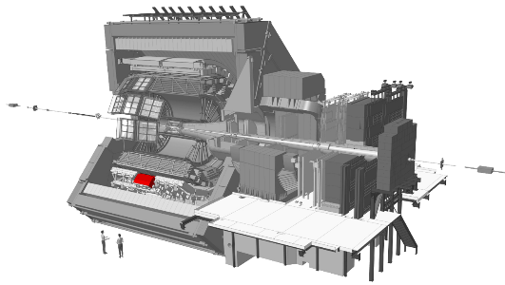

Figure 6: ALICE PHOS

Another single-arm detector, PHOS is an electromagnetic calorimeter which gives a high-granularity and -resolution view of photons, to distinguish their production mechanisms (i.e. whether they arise from thermal emission or hard QCD processes). Scintillating crystals amplify the signal to give good resolution of lower energy photons. Charged particles are vetoed by a set of multiwire chambers, inwardly adjacent to PHOS [27].

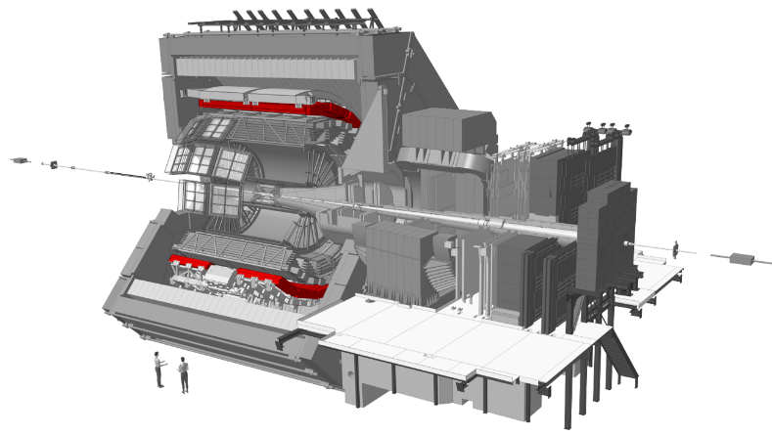

Figure 7: ALICE EMCal

EMCal is a lead-scintillator sampling calorimeter, larger than PHOS, it is used in the measurement of jet production rates and fragmentation functions (functions used to calculate the probability that specific observed final states arise from a given quark or gluon) [27].

All of the detectors in the central barrel, except for HMPID, EMcal and PHOS, cover the full azimuth, i.e. they can detect particles at all angles around the central collision area [27].

Outside of the central barrel, a variety of smaller detector elements are found (V0, T0, PMD, FMD, ZDC) that are involved in the triggering of data collection for a specific event, as well as global event characterization [27].

The forward muon arm (covering angles between 2°-9° relative to the collision centre) completes the picture of the ALICE detector (Figure 8). It consists of 14 planes of triggering and tracking chambers, as well as various muon absorbers and its own dipole magnet [27].

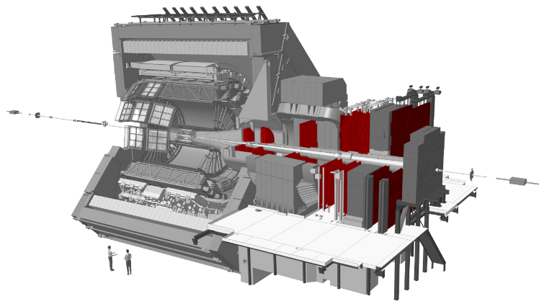

Figure 8: ALICE forward Muon arm

The measurement of heavy-quark resonance production is fulfilled by the Muon spectrometer, its small angle relative to the beam-line allows acceptance down to zero transverse momentum. It is made up of a composite absorber and ten thin cathode strip planes acting as high granularity tracking stations. An additional muon filter and four Resistive Plate Chambers are employed in the processes of triggering and muon identification. The muon spectrometer is protected from secondary particles produced in the beam pipe, by a 60 cm-thick absorber tube [27].